CAOL LAB 2 TASKS
Task 1:
include Irvine32.inc

.data
var1 byte 10h
var2 word 20h
var3 dword 30h
.code
main PROC
mov al,var1
mov bx,var2
mov ecx,var3
call dumpRegs
exit
main ENDP
END main
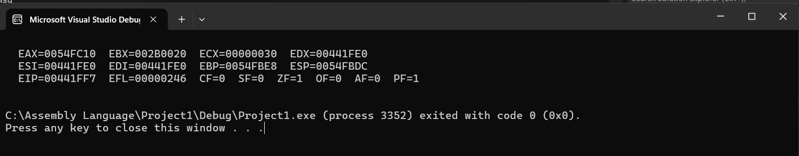
Task 2:
include Irvine32.inc
.code
main PROC
mov eax,10
call writeDec
call crlf
call writeHex
call crlf
call writeBin
exit
main ENDP
END main
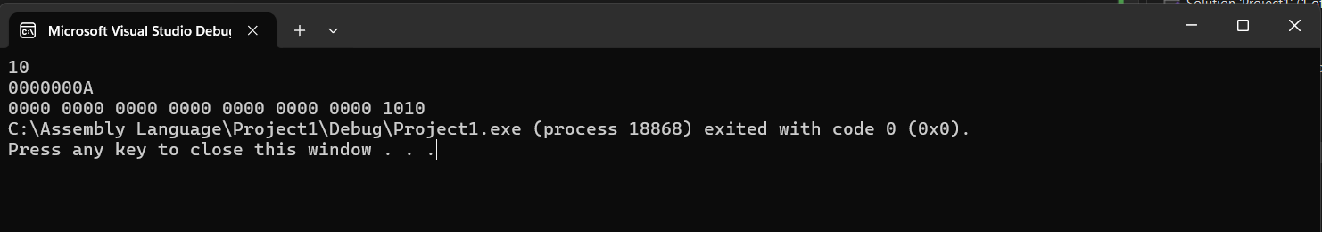
Task 3:
include Irvine32.inc

.data
num1 dword 24
num2 dword 12
num3 dword 3
res1 dword ?
.code
main PROC
mov edx,0
mov eax,num1
mov ebx,4
div ebx
mov eax,edx
mov ebx,num3
div ebx
mov res1,eax
mov eax,num3
mov ebx,3
mul ebx
mov ebx,num2
add eax,ebx
mov ebx,res1
mul ebx
mov num1,ebx
call dumpRegs
exit
main ENDP
END main
